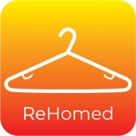
MEDIA RELEASE

ReHomed Clothing Marketplace
Contact Rogan & Kim Carroll
0447263913
contact@rehomedclothing.com

FOR IMMEDIATE RELEASE

Sydney couple have the environment and buyers at the heart of the pre-loved clothing market.
A PASSION for the environment and wanting to do something about the quickness of the fashion cycle prompted one Sydney couple to launch the ReHomed Clothing marketplace.
Rogan and Kim Carroll noticed an increased interest in second-hand clothing during lockdown, along with people doing mass cleanouts of their wardrobes to make way for new items. They also wanted to offer an alternative to people overloading charity shops with donations, because not all of them make it to the shelves.
The idea sat in the back of their minds for two-and-a-half years before it was officially launched June 2022.
"We are trying to save the environment and clean out everyone's wardrobe," Mr Carroll said.

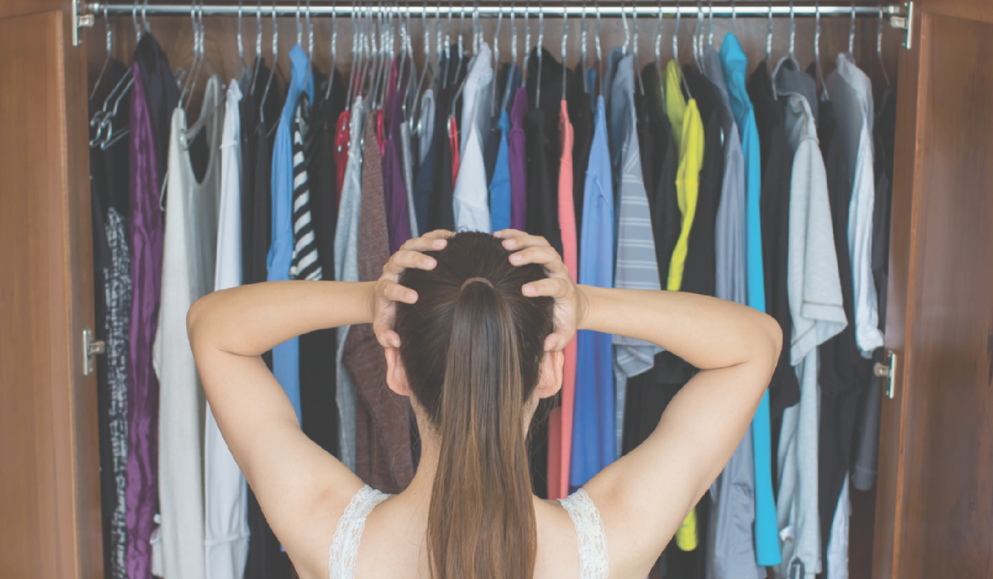
The businessman and marketer built and tested the marketplace for months this year (2022).
The couple found when people started to list clothes on the ReHomed Clothing site, many items still had their price tags attached. When they conducted initial research, they discovered a pre-pandemic survey that said one in three women in Britain got rid of their clothes after they wore them once or twice.
Simply put, the Instagram generation today crave newness, and are much more likely to embrace churn in their wardrobes.
At the same time younger generations are more interested in sustainable clothing than older consumers.
"That concept really needs to change," Mrs Carroll said.
"When I was young, I bought quality clothing and wore it over and over again."
Clothing resale lengthens the clothing item lifecycle while offering the newness these digital consumers desire.
Most people would admit to having clothes in their wardrobe that they never wear. What do they do with all those clothes when it’s time to clean out the wardrobe? Give them to a charity shop where only the best items make it onto the racks, and the rest end in landfill? Or do they just throw them out themselves?
There is no such thing as throwing them out. They must go somewhere, right?
According to the Australian Fashion Council's 2022 Industry Modelling Report, six tonnes of Australian clothing is dumped in landfill every 10 minutes.
Australia is the second highest textile consumer in the world per person, behind the United States of America, according to data from the inaugural National Clothing Textile Waste roundtable in 2021.
A submission to the Parliament of Australia in 2019 revealed that Australians consume 27 kilograms of textiles annually but 23 kilograms of it gets discarded.
Information on the Northern Beaches Council (Sydney) website in regard to waste production, revealed five per cent of waste in the local government area's red bins is from textiles, which includes clothing. This is replicated around the country.
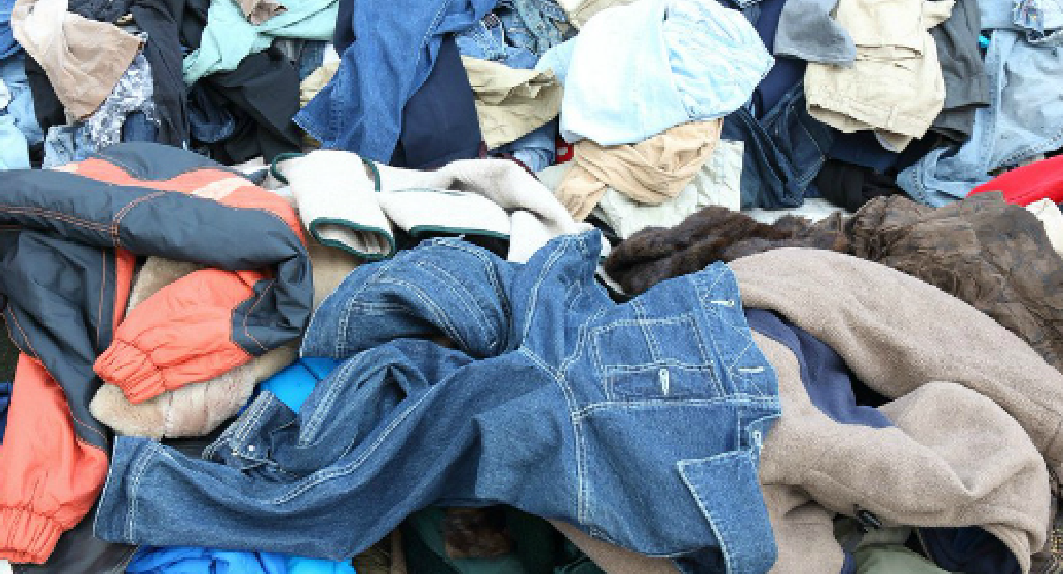

"The concept and idea had been around for a couple of years and it's not unique - there are markets with second-hand stalls, second hand clothes shops and plenty of individuals selling their finds to their own followers on Instagram," the co-founder said.
"But being the entrepreneur I am, I like to find a better way to do things, and for the masses, not the few."
One key difference that sets the ReHomed Clothing marketplace apart from other marketplaces, is the use of pre-populated filters to list products, which means buyers do not get inundated with cluttered search results as they do with most other marketplace searches.
Sellers have to use filters that indicate an items size, style, colour, material and brand which gives people a "decluttered" search with specific items they are looking for. It’s really simple to use.
Another distinct feature is items being directly posted to people, which eliminates the hassle of working out a pick-up time and provides people with security if they are uncomfortable meeting others. It also eliminates scams from people getting sellers information through messenger.
“I’ve seen Messenger scam attempts first-hand when a prospective buyer reaches out to make an offer and asks for the pickup address, or bank details, and upon profile digging, these are just fictitious profiles. Scams,” says Rogan with a sense of frustration.
Dispatching via tracked post also means the price does not change and instead of people being geographically limited to their area, they can securely buy clothing interstate.
When somebody has bought something, they are given a tracking number and the money is not released until it makes it to their doorstep.
People who want to sell their clothes are given tips on how to photograph and display items for sale on the marketplace.

The ReHomed Clothing Marketplace is for selling and buying pre-loved clothing. Clearing your wardrobe, making a few extra dollars, and helping the environment.
"It's great that second-hand clothing is cool again," Mrs Carroll said.
"I hope we all do our little piece and make a big difference."
More information can be found at www.ReHomedClothing.com

###

www.rehomedmarketplace.com
Instagram @rehomed_clothing
Facebook @ReHomedClothing

Statistics references:
https://ausfashioncouncil.com/wp-content/uploads/2022/06/2022-Industry-Modelling-Report.pdf
https://www.northernbeaches.nsw.gov.au/services/rubbish-and-recycling/waste-reduction
https://www.ragtrader.com.au/news/every-10-minutes-6-tonnes-of-clothing-goes-to-aussie-landfills
1.https://www.mckinsey.com/~/media/mckinsey/industries/retail/our%20insights/state%20of%20fashion/2022/the-state-of-fashion-2022

